**Week**: 5

**Report Owner:** Enes KILIÇ

**FACE RECOGNTION**

We mentioned the subprojects of our project connected to the facial recognition and facial recognition module in our report in previous weeks.

**Face-subsystem**

Let's examine the folder structure of my AttendanceProject.py file, which I used in my report in the first place and whose entire algorithm is mine

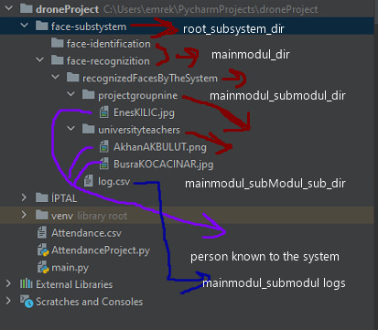

**root_subystem_dir:** The subsystems of our project will be kept in folders during this directory; e.g. face-subsystem

**mainmodul_dir:** The main modules of our project in the corresponding subsystem will be kept in folders during this directory: e.g. face-identification,face-recognizition

**mainmodul_submodul_dir:** The directory where the sub-modules of the main modules of our project are located. They will be found during this directory; e.g. recognizedFacesByTheSystem

**mainmodul_subModul_sub_dir:** The directory that the sub-modules of the main modules of your project will use for file and folder operations. E.g.: projectgroupnine represents the names of universityteachers > Group. So Enes KILIÇ of the projectgroupnine group is like Ezgi Demircan of the universityteachers group .

**Person known to the system:** Pictures of people the system recognizes.

**Note:** They will be identified as system users in the coming weeks. Some of these people will be involved in the management system and some will only be in the normal standard user role.

**Log.csv:** The file that holds log records of the subsysms of the host system.

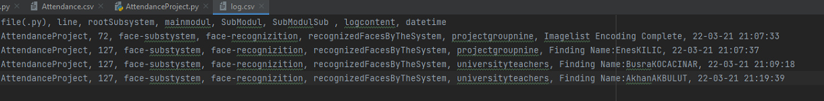

In the picture above, you see log log recordings created by showing live and pictures of the contacts on the system's camera. (**The relevant file will be discussed later in the report.** )

**Who will use the system? (UserType and Roles)**

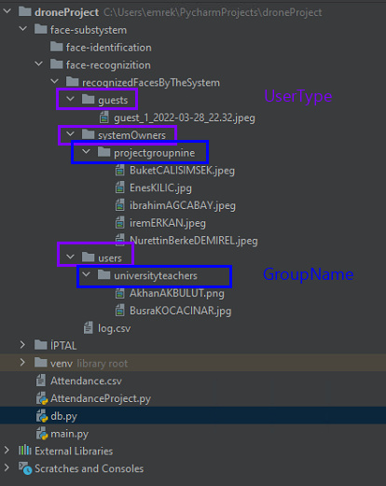

1. **System Owners:** The owners of the system are projectgroupnine group people. Information security is ensured within the system by assigning roles/powers concerning their existing duties. The Projectgroupnine group , however project owners, can pose a security threat to each other. It can happen consciously, it can happen unwittingly. Of course, in general, everyone will have the authority of the system owners to do everything. highly private data can be kept confidential)

* **Managing director (Admin):** He is the most authoritative person who has access to everything (read, write, delete) until he reaches the most critical information in the drone project.

Since there is only a console screen on the Python side , all print states are requested to be written here. Because instantly everything is tracked on this screen. This creates a significant vulnerability. Only the most competent person in the system can see this situation. In the same way, this is the case in the web state.

* **Python** **Applications:**  They are responsible for the modules related to the camera/image in the drone project. This part provides almost all the data to the system. They do not have access to and use the Web side. They can make improvements to the database side with the necessary permission and knowledge. Database management should create the vyts system , taking into account both python's self-made modules and the methods and features that will come with Sdk-based.
* **Database administrators:** The people responsible for the system's database management. They process and save **the** **data** obtained by the system as necessary. They can't get on the Python side, the web side, and the drone sdks. They are only responsible for the datasets delivered to them. This data can come from python, the web, and the drone's own features. In the drone general project, this mentioned on three sides of code security, algorithm, system flow. personal private rights such as diagrams, etc. are reserved. Database administrators are not allowed to be accessed.
* **Web Design Officers:**  They control/command and monitor the system with the database of the system or with web services xml structures as much as possible. They can't interfere without permission unless they need the Python side, the database side.
* **Drone device software controllers;**  Using the system's drone device sdds, they share the features of the drone device to the necessary units of the system (python, web and database). They have no right to intervene directly and can make necessary interventions on all three sides by obtaining permission.

**2-Standard User: They can access the** system by voice command or web interface and use the modules of the system. They do not have access to private data. The system didn't isolate it well.

**Important Note: Standard users** and **System owners** users should be well separated from each other. Standard users are members who use the system normally. They should never see the system's private functioning data. This data should be kept confidential when connected with the standard user, e.g. enes sword picture encoded. System owners should be able to see this, not the Standard user.

Another example is reflected **in the** **standard user** session

Ezgi Demircan was in the teachers group

**Reflected in the group of system owners**

Images encoded

Enes sword found in groupprojectnine group face dis 0.75

**3-Guest User: It is only very foreign people with very limited features who cannot access the** system by voice command or web interface . They cannot benefit from any modules of the system.

Only the camera opens to them; He's just going to not recognize it because he's trying to get to know it. And when you don't, you can't allow system use. We can't get someone we don't know to use the system. We don't know who to answer to. If you use the system to someone you don't know, everything stays anonymous.

**Week**: 6

**Report Owner:** Enes KILIÇ

**FACE RECOGNTION >>**

The main programming language of facial recognition technologies, so to speak, is the libraries of python and python. Therefore, we will develop these libraries, which are largely professionally prepared, by taking advantage of our project and create our own software. Let's get started;

1. **We also mention our libraries in our project.**

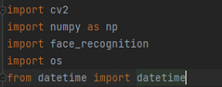

We include the necessary libraries in our project .

**2-We determine the file paths required for the project at the beginning of the project**

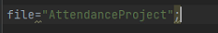

The name of the project .py file.

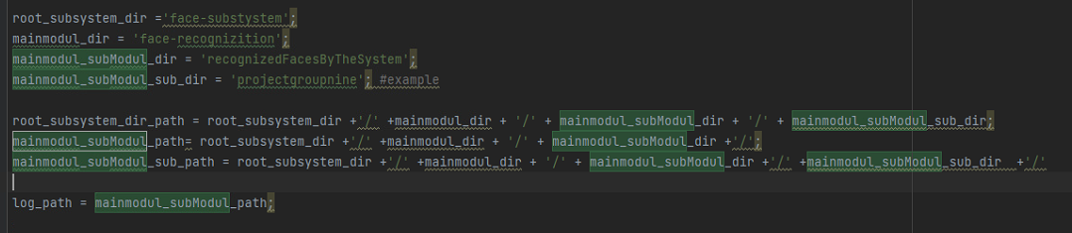

We determine at the beginning of our project file for comfortable use of project files and easy integration processes.

Log_path > specify the path to the log file where the corresponding sub-module (recognizedFacesByTheSystem) is located in the corresponding main module (face-recognizition).

**Face-recognizition (Main Module)**

**recognizedFacesByTheSystem(Sub-Module)**

This sub-module has been created to add various features to the system with previously introduced contacts.

In my study this week, it was assumed that the following people are system users and will be so oriented in the coming weeks.( Some will be people from the management department, others will be standard users)

**3-Regular withdrawal of all persons to the code side depending on their group**

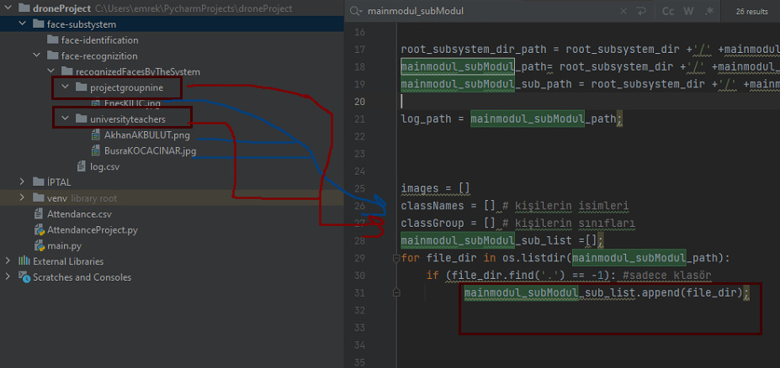

**Orange boxes;**  Groups of people recognized by the system, e.g. Enes KILIÇ from projectgroupnine group

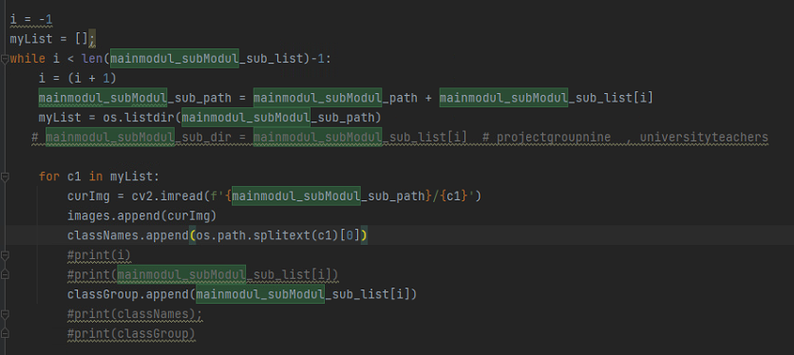

**ClassGroup** [0]: **Projectnintegroup** > **ClassNames[0]: Enes KILIÇ**

**ClassGroup[1]** : **Universityteachers** > **ClassNames[1]: Ezgi Deriving**

**Functions**

1. **Method to use system images in binary way in all image operations**

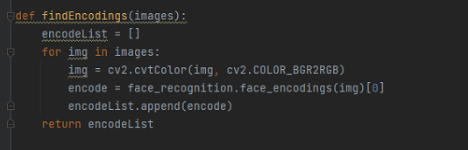

1. **Writes to attendance.csv**  file as soon as  **the camera recognizes** users who exist in the system  **.**

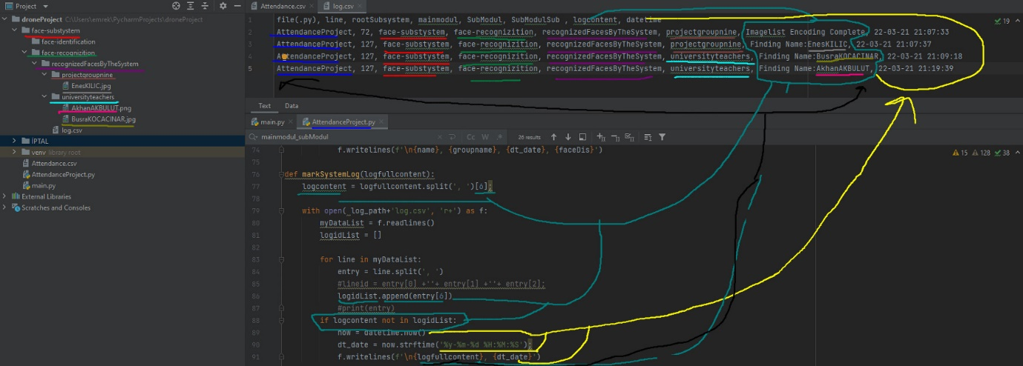

According **to groups** of users who exist in the system , according **to instant datetime** and the similarity we call instant **faceDis**,(the closest to 0 is less recognized than 0)

**RUNING(RECORD 😊** **)**

1. **Basic Human Face Determination Process**

Most basically, let's start facial recognition first. How to distinguish a person's face from any picture ?

First, let's give a simple example.

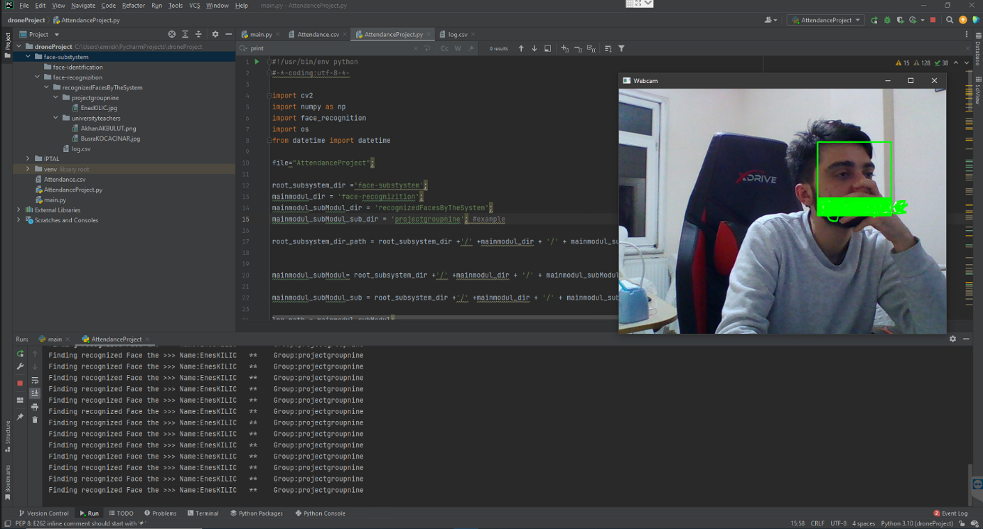

As you can see above, even if you cover the human face with your hand, it can understand and expresses it in the form of a green rectangle.

1. **Human Face Recognition and Keeping Related Records**
   1. He knows and knows Enes KILIÇ, who was previously registered in the system.

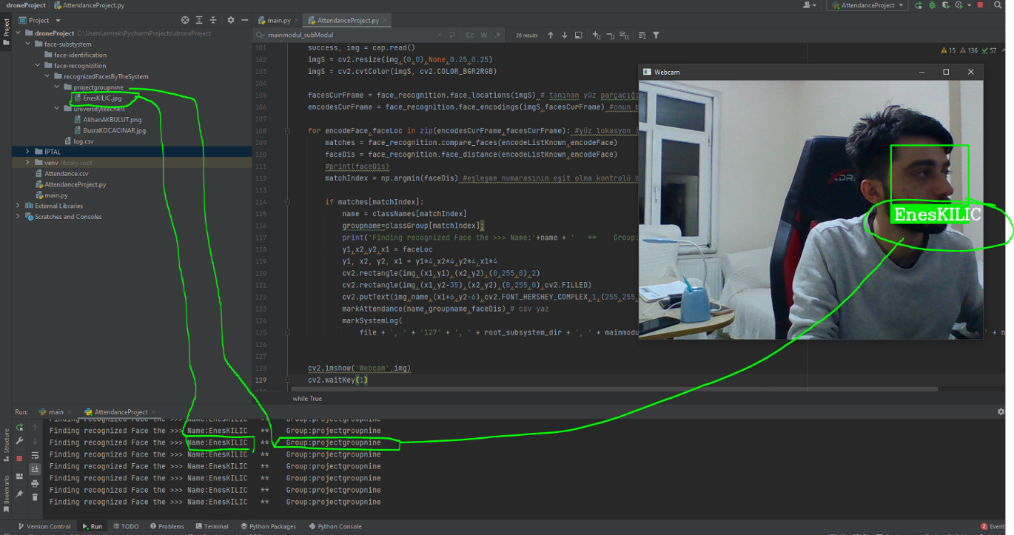

b.The system writes the name-surname of the person it knows and the group it is in on the Consol screen.

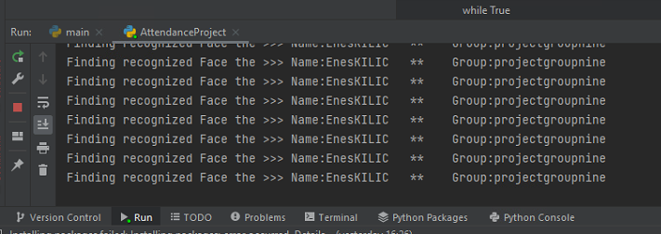

b.The system recognizes the surname of the person it knows, the date and time it recognizes, and the degree of recognition (the closest to 0 is the less well-known, the furthest from 0) **attendance**. **writes csv**

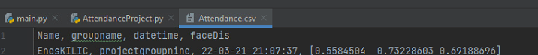

* 1. As with any action, the system writes details of the exact transaction to the log.csv file in the sub-module of the relevant engine.



**Week**: 7

**Report Owner:** Enes KILIÇ

**SKIN AND AGE MANAGEMENT (MULTIFACETED)**

* **Libraries that may be required and their contents**

Unlike past reports, I did not import any libraries . The libraries we need in the operation of the project are indicated in the appendix.

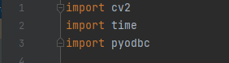

I had gender identification in the project I presented last week. I did this using a pre-trained model , using trained data. A detailed explanation is in that report.

In this section, we will define age information using pre-trained models.

* **Pre-Trained Models**

In this project, we will use prototxt and caffemodel as well as the same sex . With data, it was trained entirely focused on age and face appearance. That's why I'm only going to use it as **an age**.

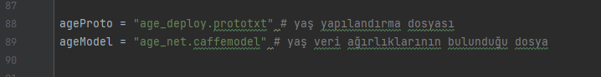

As with gender files, there is one file with config and data weights.

All our pre-trained models are indicated in the appendix.

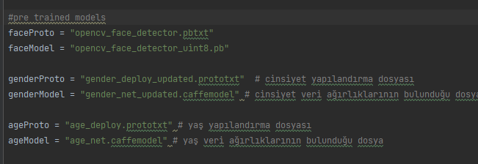

We are able to encode this data with the **"ReadNet"**  function provided to us by OpenCV . Here we use the method called **Deep Neural Networks**, which stands for **dnn**, called Deep Learning in Turkish. I can prepare another report for background operations, if you wish, for learning methods, etc., but I am not explaining it because it is not currently connected to the project.

Encode operations with "**ReadNet"**  . I gave you the detailed information in the previous project. In the same way, we use  **"Deep Neural Network"**  operations with the abbreviation "**DNN**". This function makes data workable.

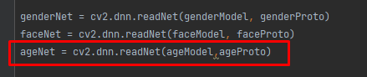

We process the renderable data again with **"BlobFromImage"** .

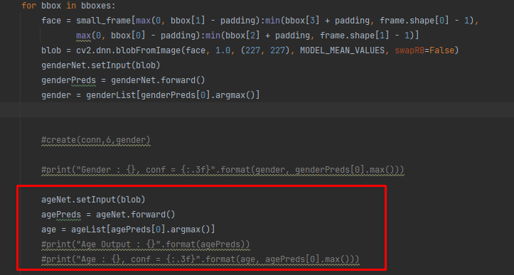

In addition, the camera can detect multiple people. I was able to detect multiple people with classic algorithm data identification processes. He could have done it before, but when the camera picked up two people and dropped back to 1, there was a loss of frame. My computer camera works with 30FPS. When it fell to 1 person, it was about 5-15. This is optimized and now works smoothly.



Result:

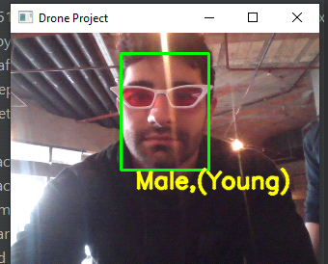

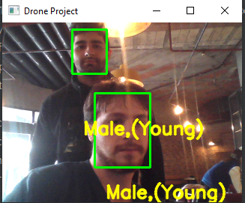

**Week**: 9

**Report Owner:** Enes KILIÇ

**COMMUNITY OPERATIONS**

Our drone project can be used not only for individual service, but also for community operations.

Our world is getting more crowded every day. Indirectly, many objects are produced more and used more. In this case, we, as owners of the information technology profession , collect and analyze data in this sense for instant or later benefit and use.

Let's look at how we use it in our project;

**1-Object/Live Determination by Classes**

Our drone project has a structure that can be used simultaneously in both outdoor and indoor environments and collect data for various analyses.

Of course, computers don't have the ability to perceive like the human brain. We have to teach them first and then wait for them to know. Let's take a look at what I taught our drone first.

For this, there is a list of all this in **the coco.names** file located under the classes folder under the data folder of our project . Let's see, let's see.

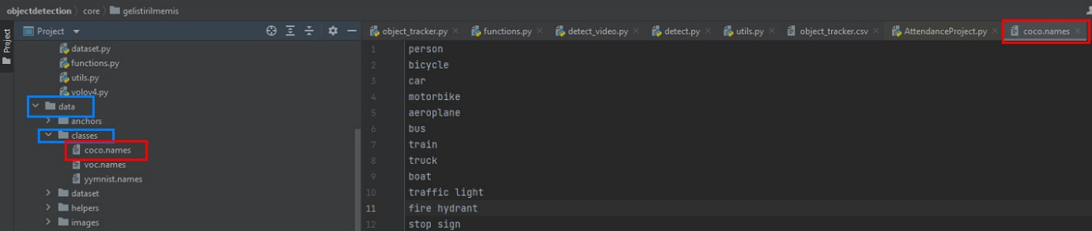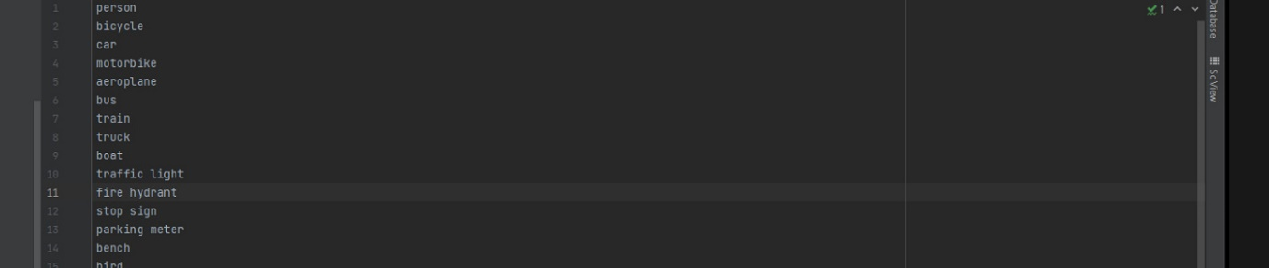

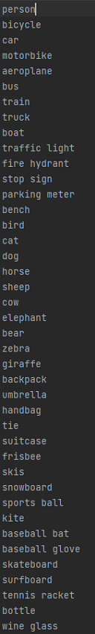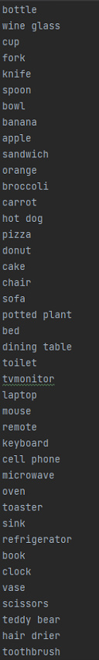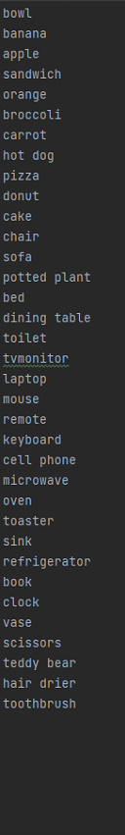

Our drone software recognizes the objects above and assigns them id when they see them, making them unique. That way, he never forgets it until it closes because it's open.

E.g.: He saw me and named me '**Person - 23**'. He'll look at me with **the same id** every time he sees me.

Our project can be recognized in three ways;

* **Most importantly, when you're on the air (live recording);**

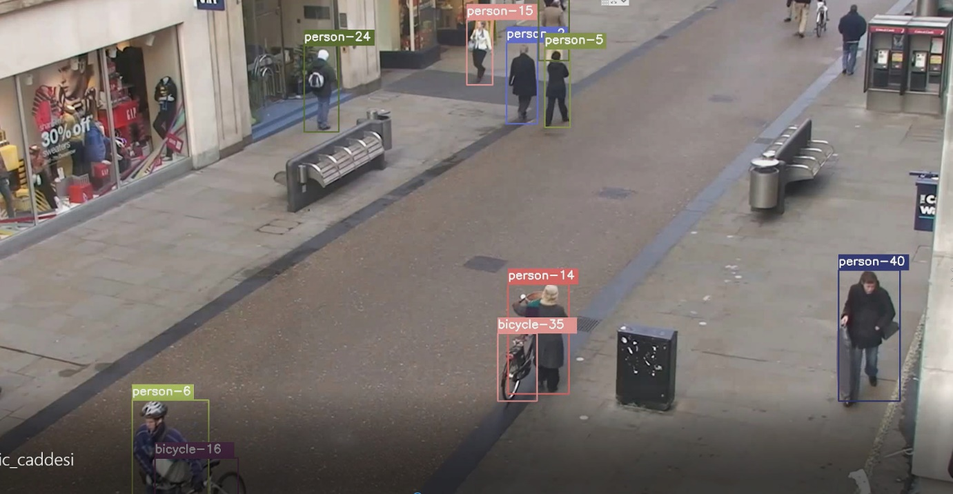

python object_tracker.py --video ./data/video/test_online.mp4 --output ./outputs/test_online_detected.avi --model yolov4

* **By looking at the previously taken picture;**

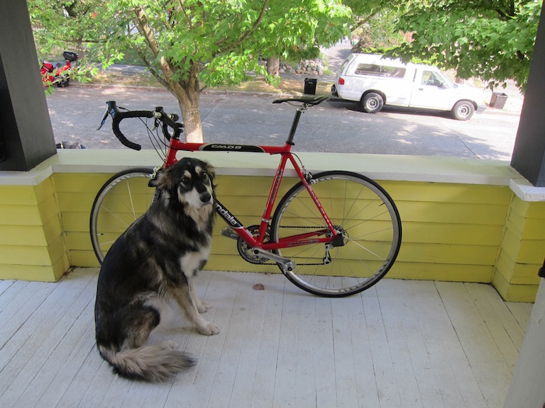

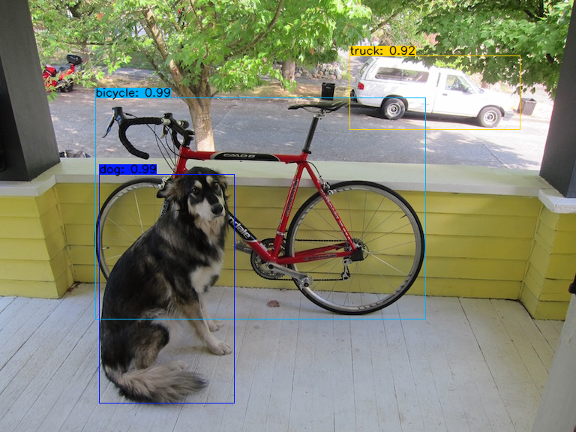

#python detect.py --weights . /checkpoints/yolov4-416 --size 416 --model yolov4 --images ./data/images/dog.jpg --count

* **By looking at the pre-shot video recording;**

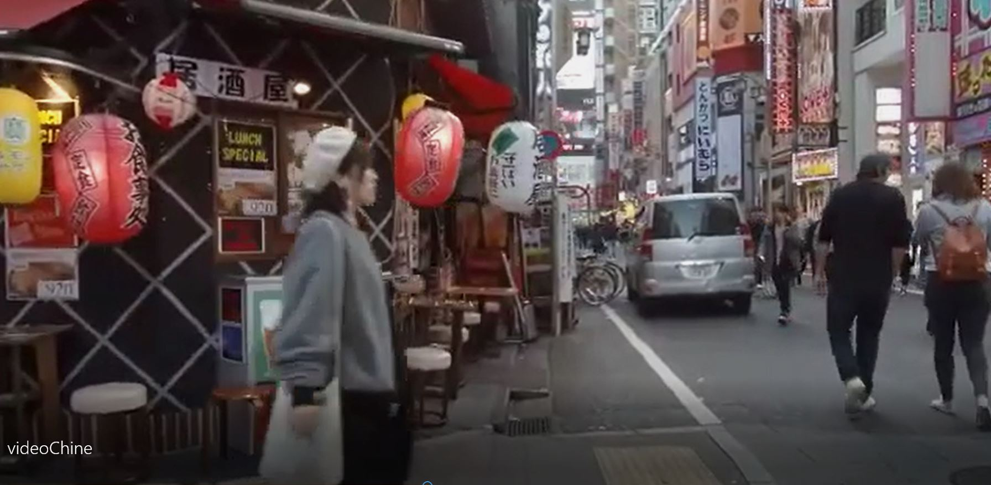

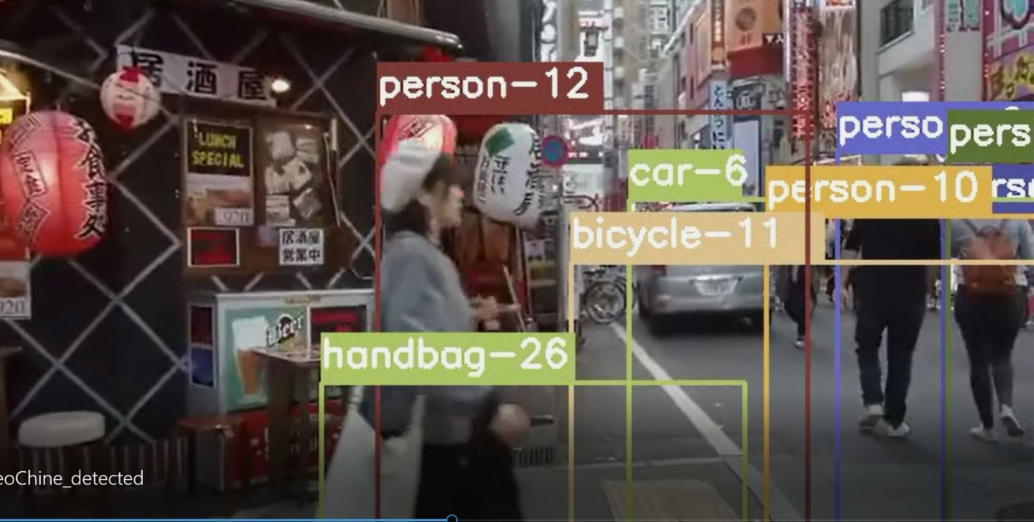

python object_tracker.py --video ./data/video/videoChine.mp4 --output ./outputs/VideChina_detected.avi --model yolov4

I get the above images and videos from the folder structure below;

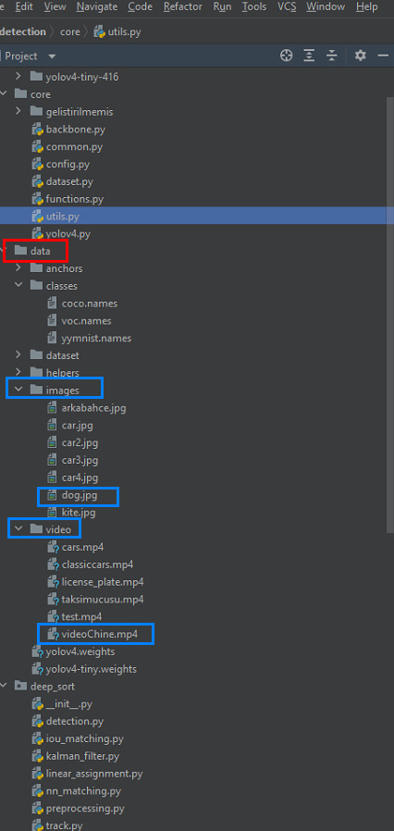

There are only a few basic examples above. It can be introduced and used on other entities. In this way, our drone camera records what it sees in an orderly and beautiful way. In this way, we can examine the environment and make specific analyses.

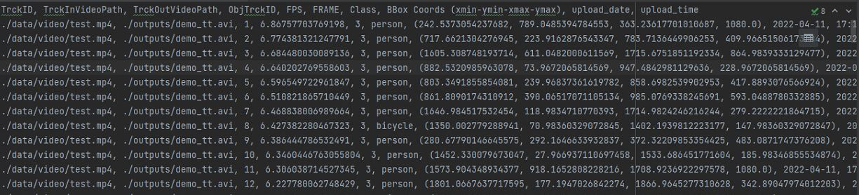

System-processed videos are processed and streamed to the **outputs** folder

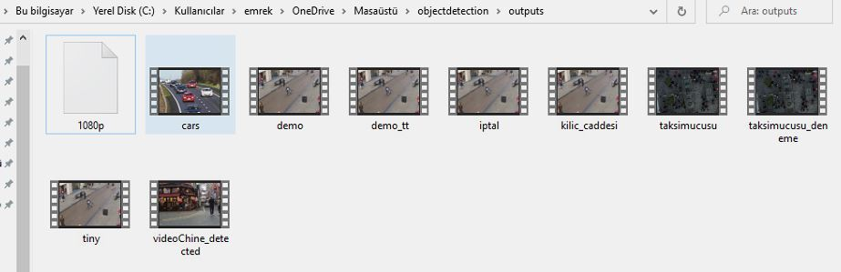

The pictures are in the **detections** folder because I want to crop and separate them from the videos.'

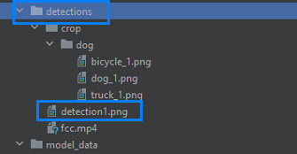

**Note:** Live recordings are processed as video and recorded instantly.

Yes, we collected the data and recorded it for analysis. Of course, more detailed results will be obtained when analyzing and reporting , but I want to see at least immediately which objects he saw in that moment. Thus, we get results faster;

**2-Object/Live Counting by Class**

* **Counting with** Live Streaming

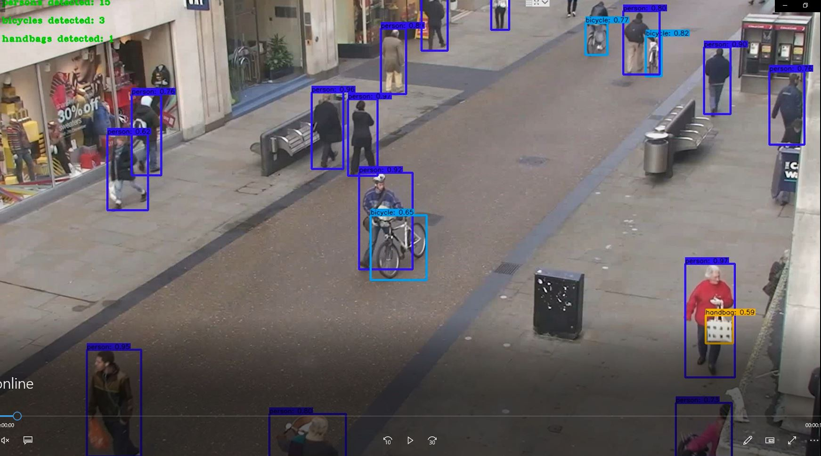

* **Counting with Picture**

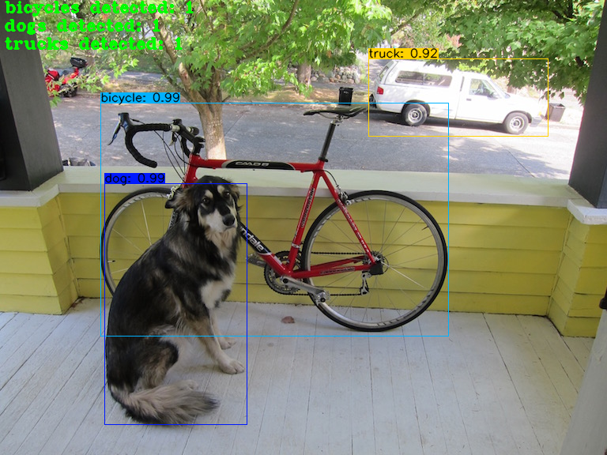

* **Counting by** Video

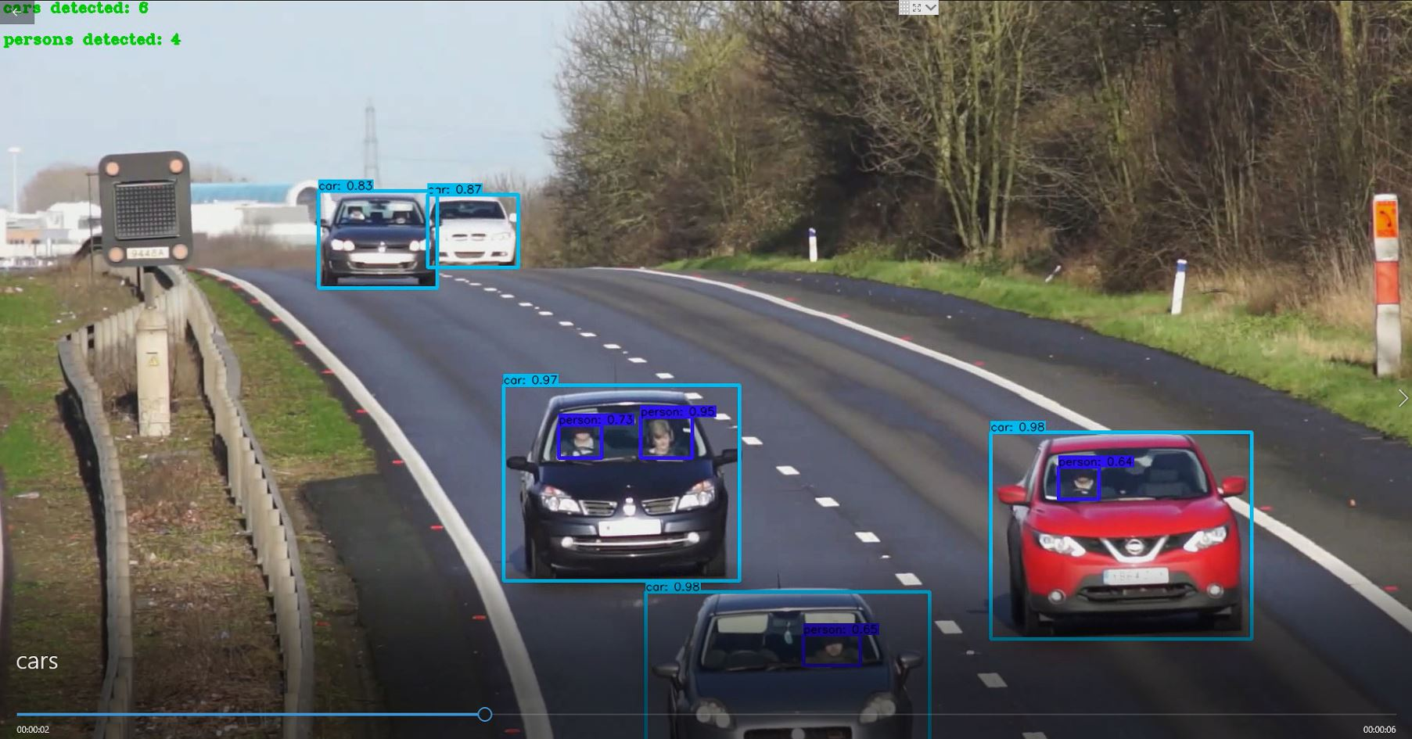

**3-Crop and Save entities in a picture**

We might want to crop and save objects in a picture. In this way, we can perform much more automated data analysis

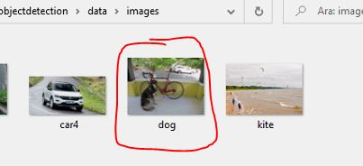

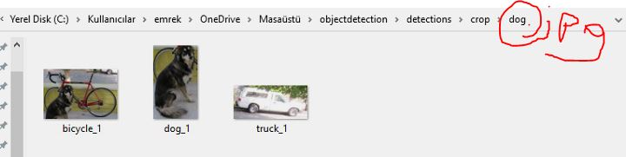

#python detect.py --weights . /checkpoints/yolov4-416 --size 416 --model yolov4 --images ./data/images/dog.jpg --crop

**EXTREME TAXI FLYING AROUND 😊**

**ARE YOU READY?**

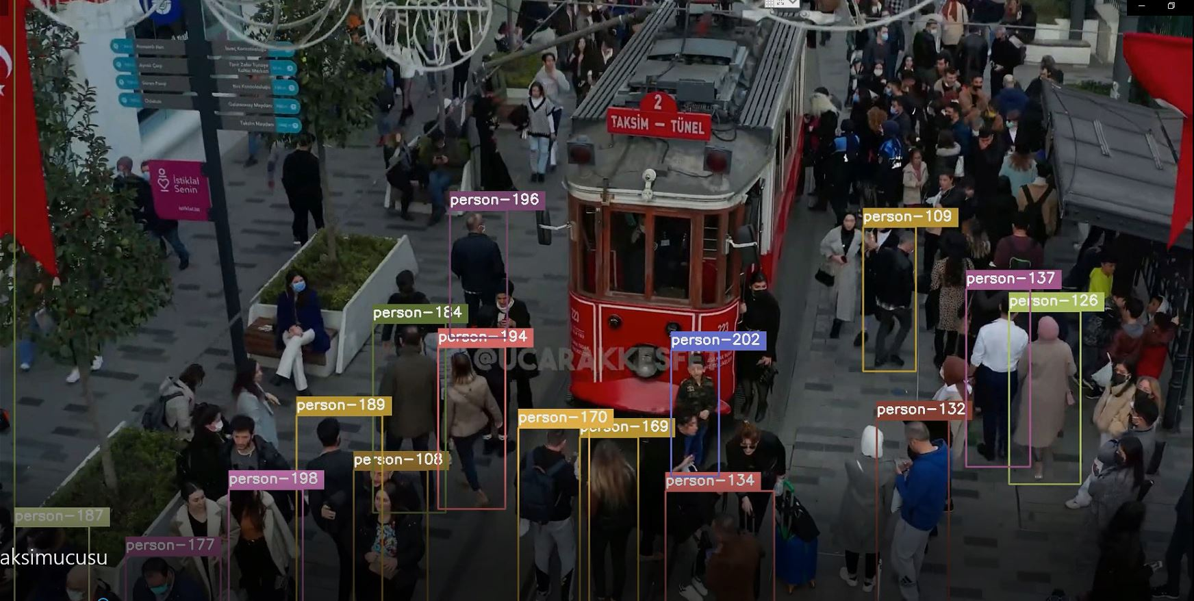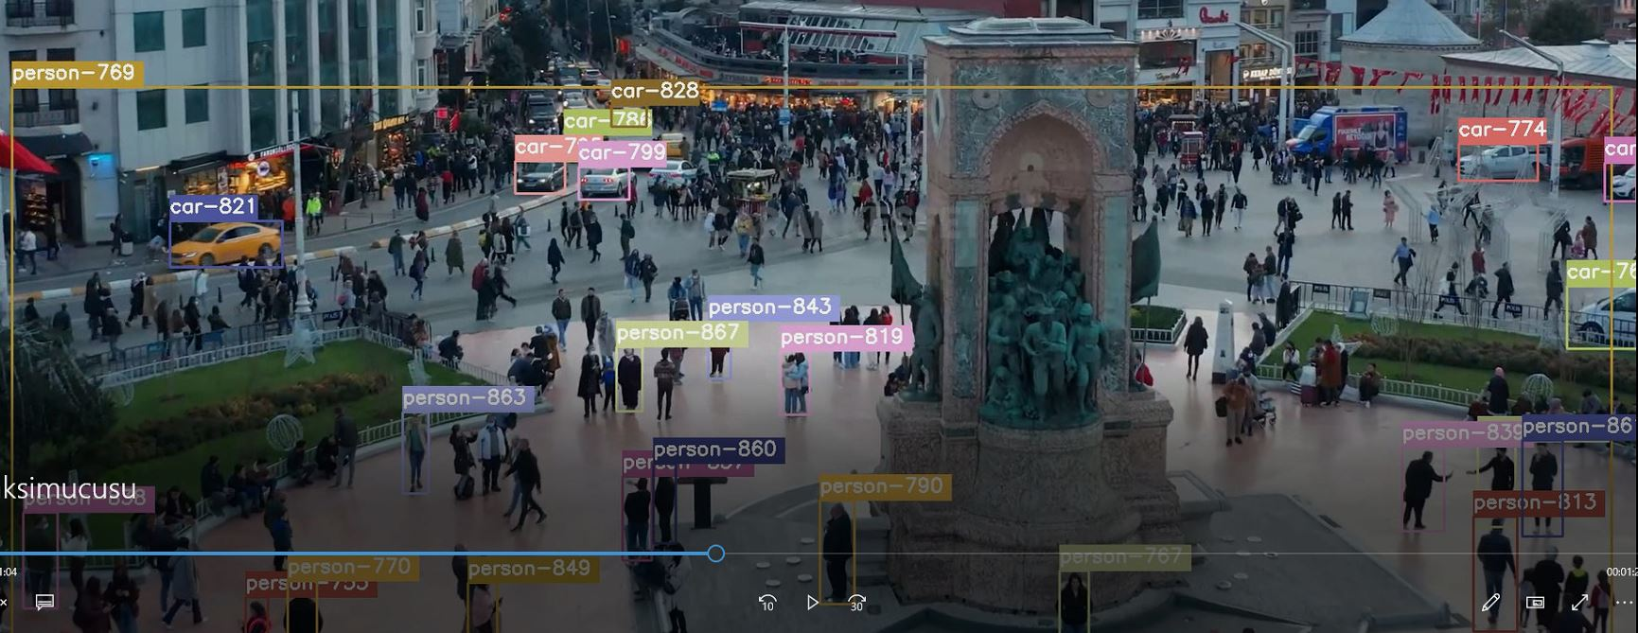

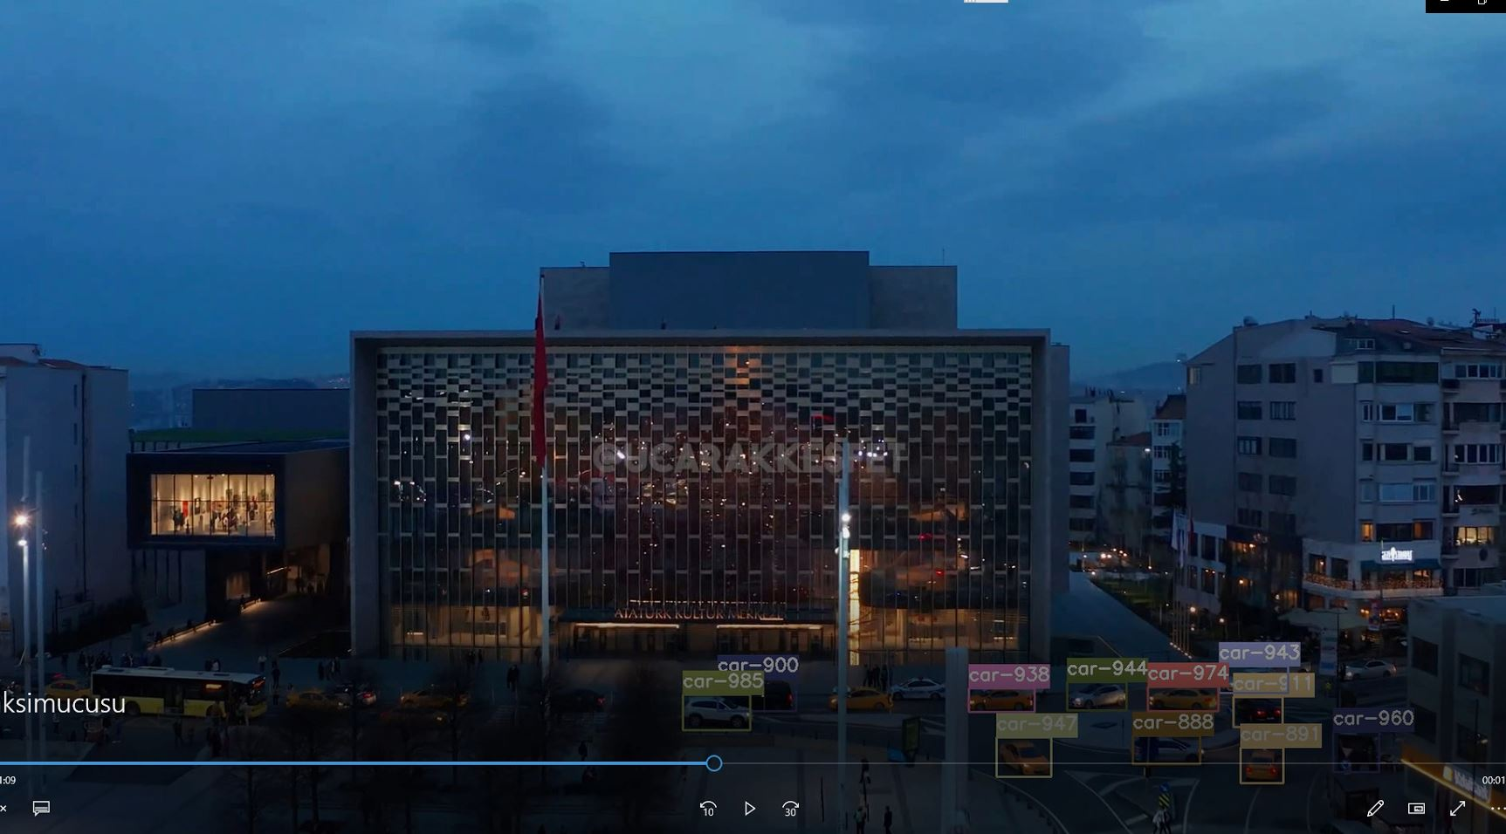

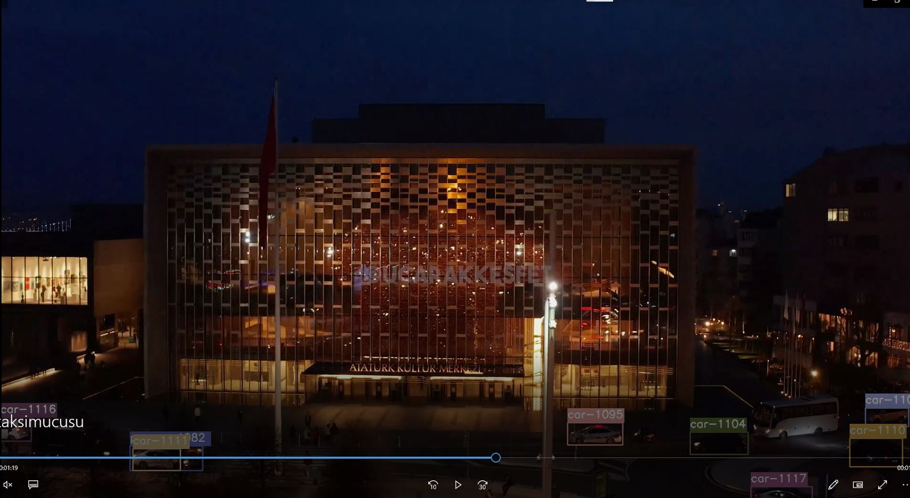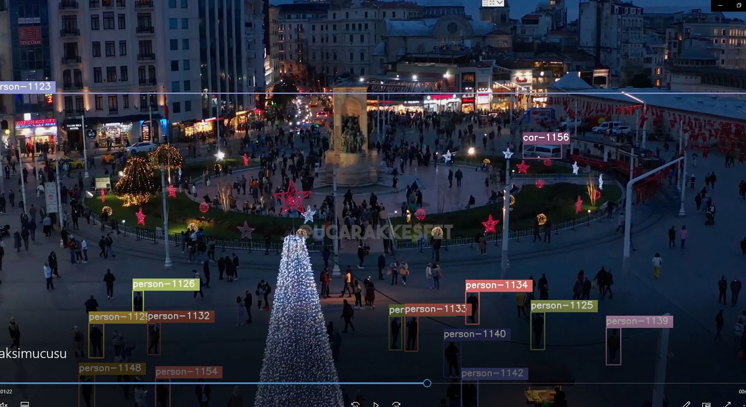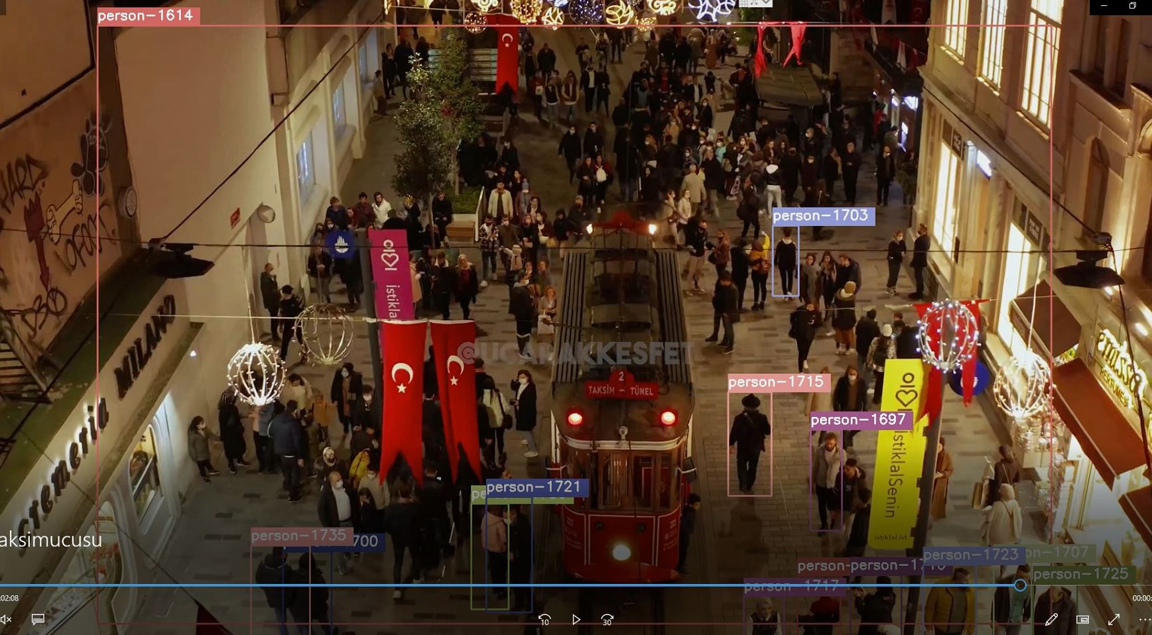

**DATABASE LINK**

The database part will be discussed in great detail after the visa week, but this week we will use MSQL SERVER 2019, the database provider that is suitable for the system. Integration studies have been carried out on this system and are ready for use.

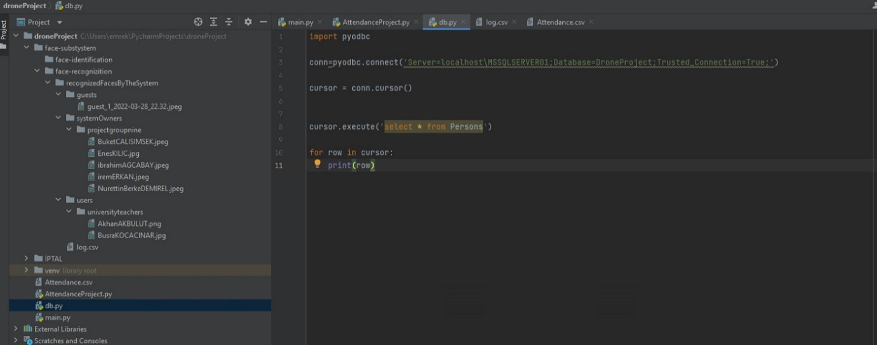

**Week**: 10-11

**Report Owner:** Enes KILIÇ

**OBJECT MEASUREMENT**

We've classified the artifacts in previous weeks. This week, we'll also examine the size of the objects.

First, let's parse the objects in a picture and examine their size.

Let's see how we do this step by step;

1. **Finding Countours**

By finding Countours of objects, we can more easily identify them and get their analysis. To do this, we use the CV2 structure of the OpenCv library. In this structure, we use the **Canny** method.

First of all, we're turning the picture into a gray version.



With **GaussianBlur** behind it, we make the picture blurry, allowing us to see more comfortable lines of countours.



**With the Canny** method, we detect the object borders with the threshold value we have already determined. The higher the threshold value, the greater the density of contouring, and more prominently, it will also find contours on the surface of the object. Even the deformed dots of the wooden table are visible in the left picture.







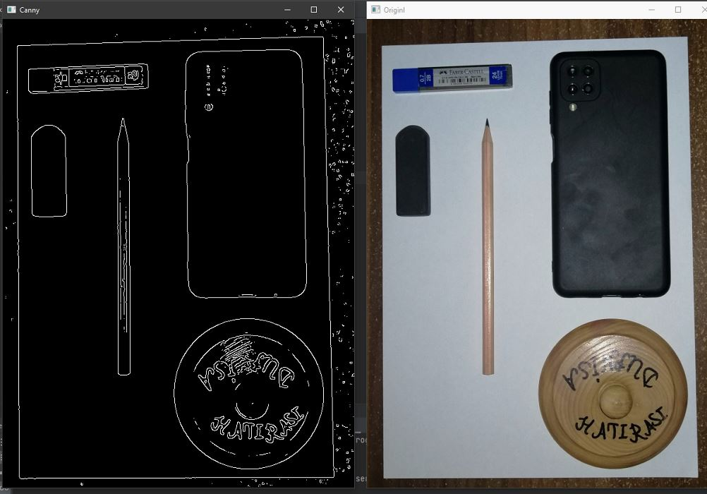

Let's apply some expansion and erosion to have good quality edges

1. First of all, we're building a core.



1. Then we use **the dilate** library to determine the iteration on the contoured picture that we have determined with Canny as 3. . (iteration > refreshes around the core) . This gives us image expansion.

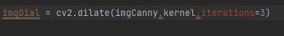

1. We use the same kernel size and set the number of refreshes around the core to 2 this time, allowing spot wear to expand the image we have expanded. We also set the refreshes around the core to 2.



We've removed the image threshold and you see there are smoother edges now

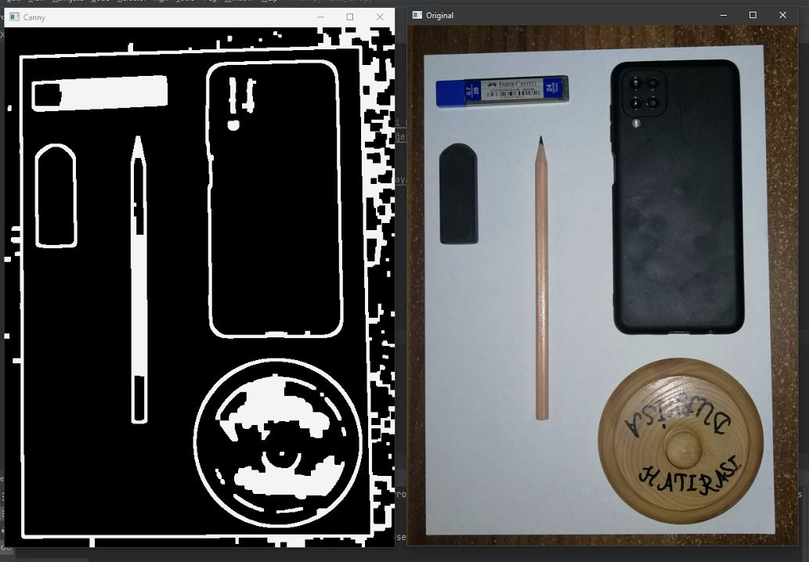

We switch to the next strokes and use the find stroke function

We use our contoured image, which is the threshold, together with its external mode because we need external borders . We use a chain approach. To open and use conturs, we write a code that says



Why am I doing this? Because then I can move around these conturs and find and draw their areas and see how well we detect them.

Let's start walking around our contours;



We find our Countur area



We will filter by minimum threshold area



We need to set a minimum area so there's no too little space so we can call it a space, sir.



Let's calculate the length of the two-point arc. First we will send our stroke as a parameter and then when it is closed (no open-ended lines in our picture so we will not say true)



Now we find the corner points;

In doing so, we use the approxPolyDP method again, we just need to point out that the CV2 library is in the closed range with the resolution values of our strokes, which come in turn looping when using it.



Finally, we can find the limiting box (bbox). So we can make it more approximate and with it we can see the point limitation. I wanted to point out with the limiting rectangular box. In doing so, we will send our approxPolyD as a parameter.

All of this will reveal to us the information of our existing perceived object with a more detailed border and more detailed corner.

Well, let's just say I want to see four-pointed objects , what do I do?



This would be a filtering exercise.

If our approach is equal to filter value, we will put it on our final list ;



Let's create our final list; that is, let's save our last strokes to our final credit list and send the approximate number of lengths (len(approx)) and the corresponding countor area(area), then send our approximate points and then our limiting rectangular boxes (bbox), which we find, together with general function information (i) and store our final strokes in the array in its new form;;



The next thing we can do is sort these strokes by size, which is useful to us , for example, we want to find the biggest contour by referencing the size of the A4 paper. If we sort it out, we'll find the biggest contour.

Let's sort our final strokes with sorted method , in doing so we will use our **area** countur field as the 'key' value. So that means that you're not going to be able to do anything about it. **sort by size of the field.**

In doing so, we use lambda inquiry ; x1 will be the area x0 length and we expect everything to be in increasing order and we reverse typing to ensure that the greatest value is the first



The last thing we're going to do is. We will use our identified contours by drawing and see if we have identified the appropriate ones

We turn around on the list where we keep the contours I found and start drawing our contours. Since it is a multidimensional array when drawing, we need a contour fourth element, after each sequence we will determine the color values and thickness ratio, and after sending all these parameters, it will start drawing new countur.

In case our user wants to draw;



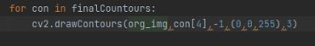

Our function ends here. As returning values, we rotate our original picture and final stroke sequence.

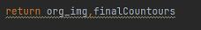

Let's rework our picture with our last found contours;



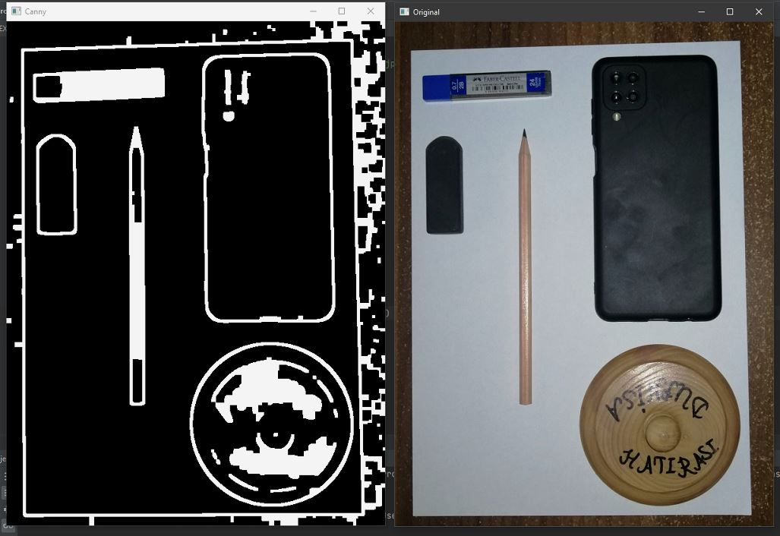

1. **Find A-4 Paper**

I had to optimize our last credit-taking phone call to find the A-4 paper.

When we call our final contouring function, we start by entering a minimum area and then filtering according to 4-point objects by filter=4



**We will use this for approximately 4 points by taking Len (approx) and approx values**

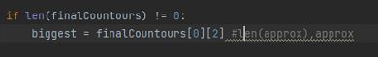

Let's find the A4 paper.

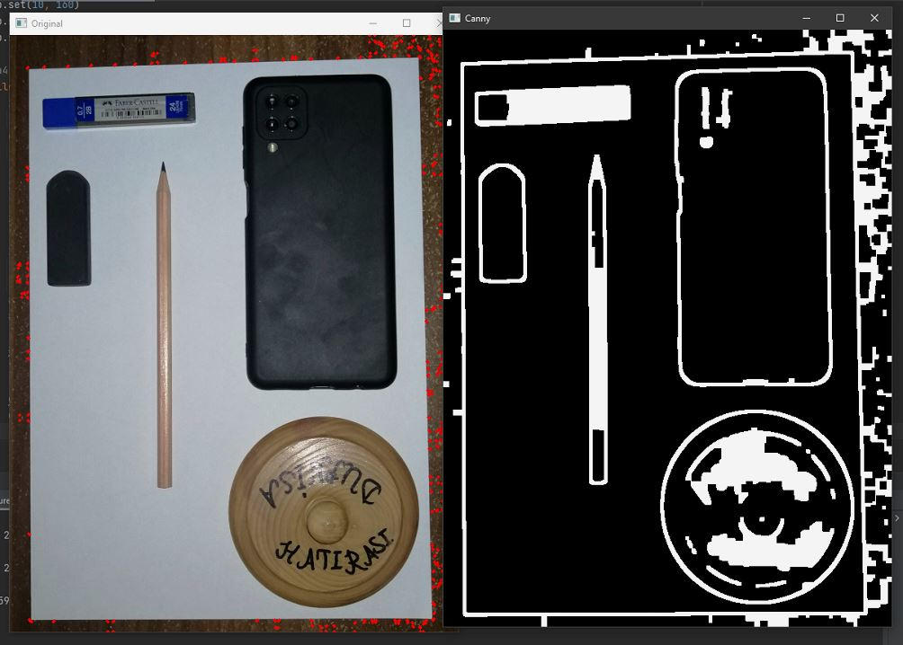

4 corner points

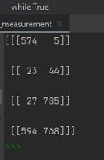

Four corners came out of order, so here's the thing.

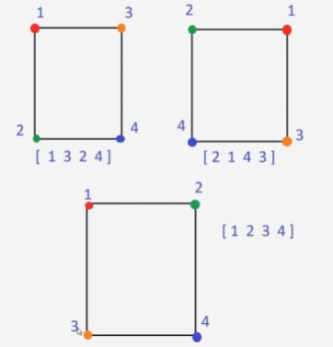

We need to make this sorted according to the bottom frame so that we can access the picture corners comfortably and neatly, and most importantly, wrap it up by adhering to the width and height value. So we need to find out where the width and height are. For this we use the function I showed below.

The image itself will send points, width and height values as parameters

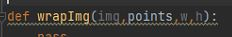

Then we'll reorder our dots.

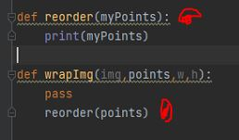

When we run our funding

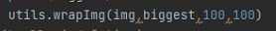

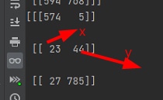

But there are three points. We're going to reshape it four to four to two. We want four dots, so that's why we're doing it.

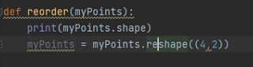

Axis will make a sum of one in 1, giving us the sum of each point. The smallest of these points will be our element, the zero element. The highest will be maximum. One will be the width, one the height will be our corner point.

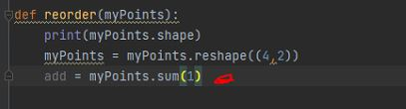

The new point is equal to five points zero(5.0).



Let's assign the smallest element in the insertion list to the zero element of this new array



Now we'll get the maximum value of the new value.



We adjust our points according to the axis one.



We're getting minimum and maximum.

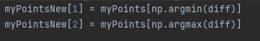

Our new spots are ready;

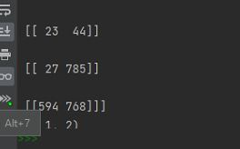

Now let's run our picture based on these points;

Then let's create our matrix;

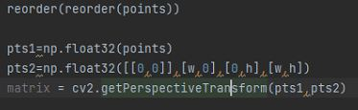

And now our wraps are ready.

Now let's write down the approximate width and heights of a4 paper;

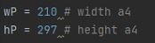

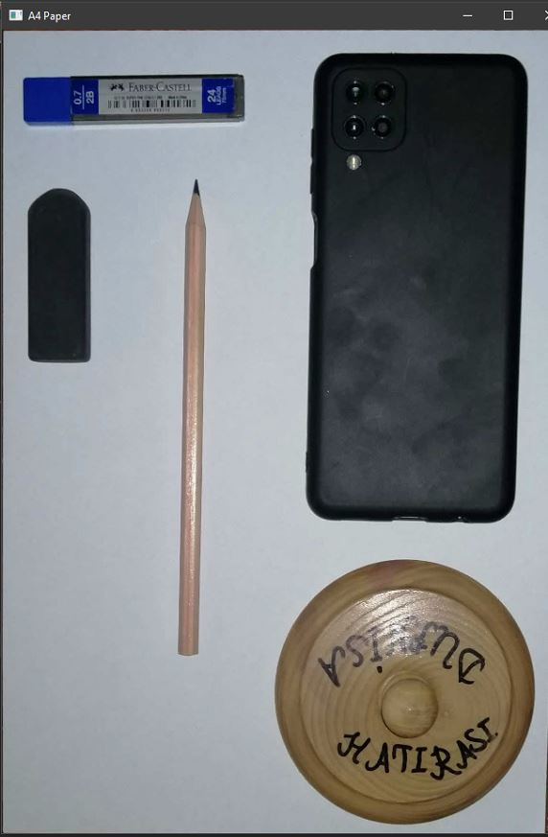

Now let's identify the objects on the A4 paper.

We're recalibrating countours values, this time for objects and not a4 paper.

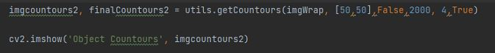

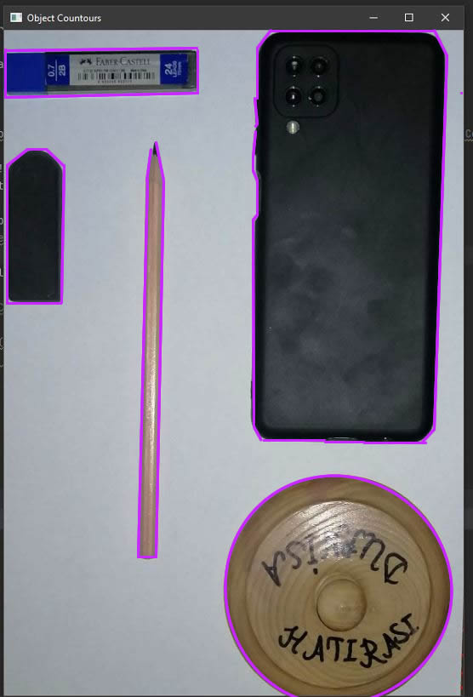

Now let's find their size.

We find the lengths of the strokes with the following method;

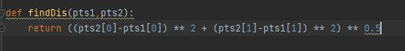

We find the length of the object by measuring the distance between the two points

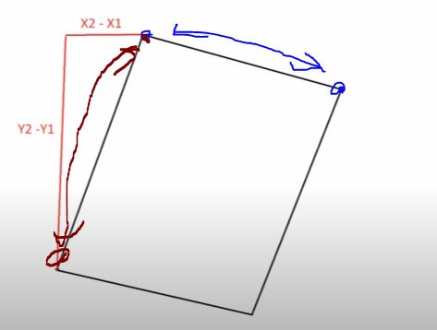

To make the edges better specific, I do the following rectangular operations

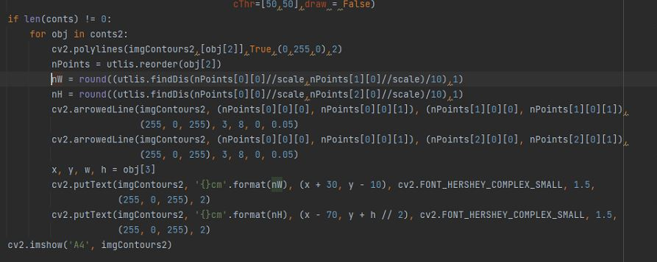

I thought it would be done comfortably on the soft edges while my teacher was doing it, but it gave me a bit of a troubled output. I do, but he's been able to work on more card-level things. I fixed this with a different study, but I didn't want to delete it because I was trying so hard.

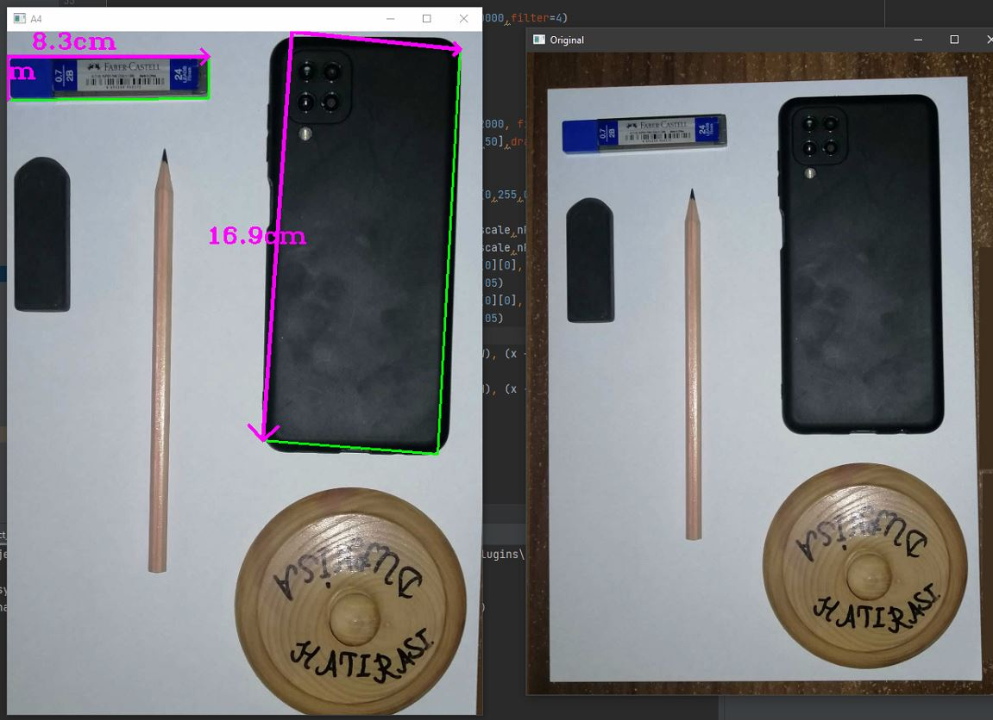

I fixed it with a different study;

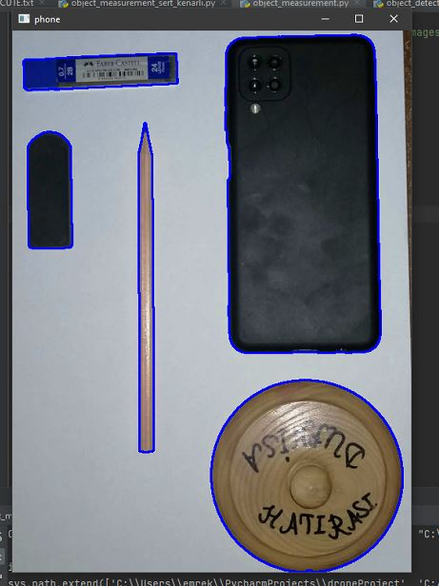

You see the x and y coordinates of the objects, the height and width of the objects, the angle values respectively, and now let's integrate this.

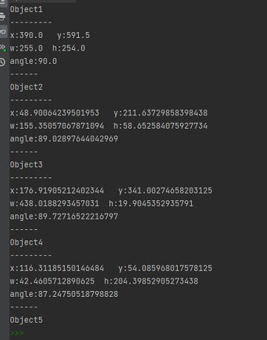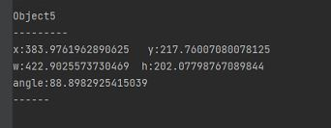

In doing so, let's use the centers of objects

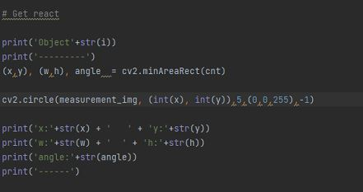

You see the centers of the objects in the picture below

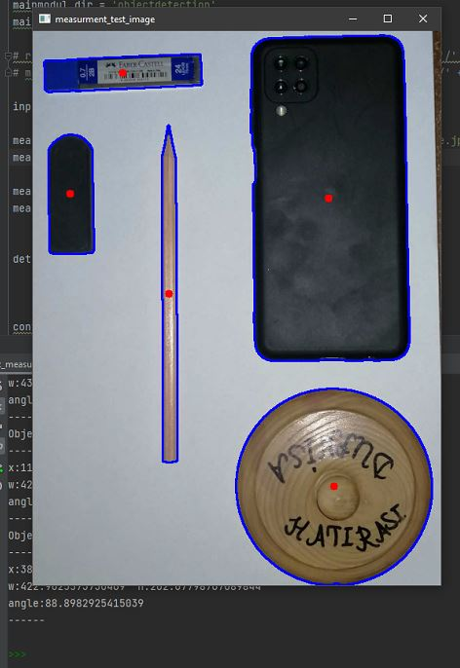

Now let's find the endpoints, first let's see them as numerical values;

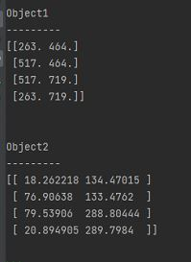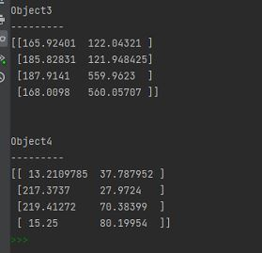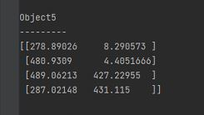

I have to convert it to an inn number first to accept an OPEN CV.

That's how I translate it, for example.

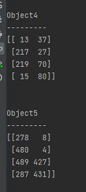

Now we make our object identifications with the blue line we make using the polyLines method by means of rectangular, boxing method.

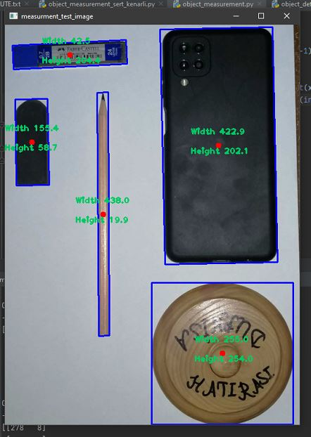

Teacher, I was going to write this down in sanimetres, but the cv2 aruco method didn't work, so I couldn't.

Now let's see the size of your phone live;

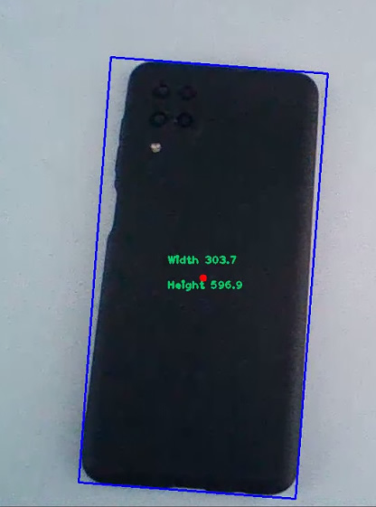

**Week**: 12

**Report Owner:** Enes KILIÇ

**LICENCE PLATE RECOGNITION**

**(ANPR - OCR)**

The license plates of the vehicles are unique. If we recognize these plates and write them down, we can use them in various studies.

Step by step, let's see how we do this, and I did it with what we learned in class;

1. **Apply grayscale**

For better and better quality plate reading, we first grayscale our vehicle picture.

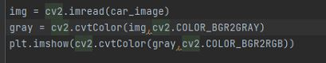

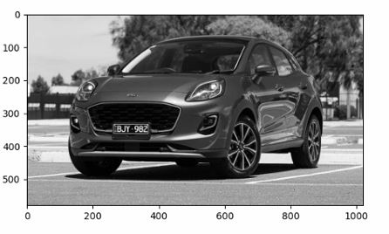

**2-Cornering/Smoothing/Noise Removal**

We move on to removing the noise from the image, softening it and edge detection, which is essentially needed for analysis.

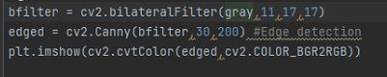

As you can see in the picture, the writing has become more pronounced;

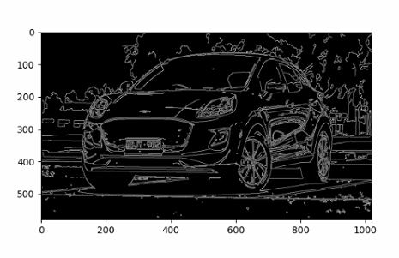

Now we're making a credit with four points because it's going to correspond to our license plate.

In the following code we copied and gave parameter edges, then tried to approximately what it looked like, so we found the key points. In a bottom line, we found the strokes of the key points we found and stored them in the countours array. This actually simplifies how our strokes are rotated, and then we reviewed and sorted them and returned the first 10 strokes. We sorted it by contour area, adjusting it from high to low.

**3-Contouring from Key Corner Points**

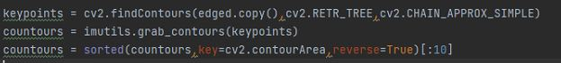

Now we're going to go through these dots and try to find four key points, the license plate. In the following code we estimate the range from our contour, it allows us to determine how accurate or finely grained it is. There is a contour with a lot of small notches in it, it rounds it to this counter how high we put a polydp, so for example it looks at that something that is roughly rectangular and the more it is roughly the smaller the dent line and punctuation, and indicate that this is really a straight line in this regard 10. is ideal.

That's how we found the license plate box, but we can't see it. So what should we do? Of course it's masking. Let's see, let's see.

**4-We determine the estimated plate by masking it**

Creates an empty mask in the following code, and then uses np zero to create a mask that will make our original gray image the same shape. We did this through the shape of a gray dot and then we determined how we wanted to fill it, and in this case we set the NP to eight, so we basically fill it with empty zeros, then we draw our contours into this image so that we create our mask, which is our temporary image.

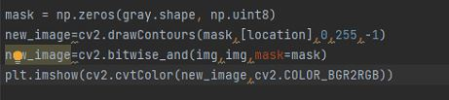

And in this mask comes the image we see below.

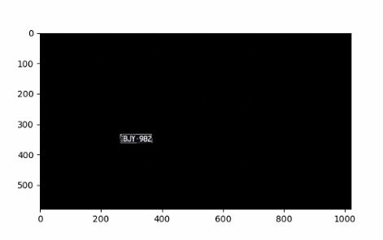

Yes, some of our plates have been successfully identified. Now we read our license plate using ocr of this mask picture, that is, by writing the picture in writing.

Of course, as you can see above, there's a big picture of empty darkness. Let's split up the little section we need.

Here's what we're doing. We adjust the height by adjusting X to x-two plus one, that is, about 30 units, according to the pilot, and we do the same logic y-to-two in the same way. X is the end of two and y two.

**5-Specifying masked plate**

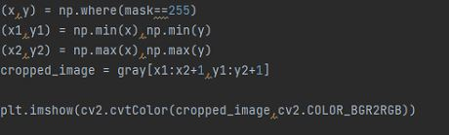

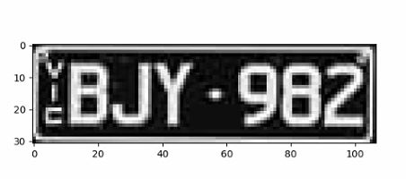

**OCR**

Now let's write down the license plate we found and get our data;

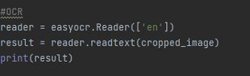

That's how he makes a show when we read the picture.



**Note** here E = VIC.

Let's get our license plate from this show and then put it on the real car picture.

Since the plate writing in the series is the sequence in the array, we reach our license plate information by coming to the zeroth series and -2 from the end.

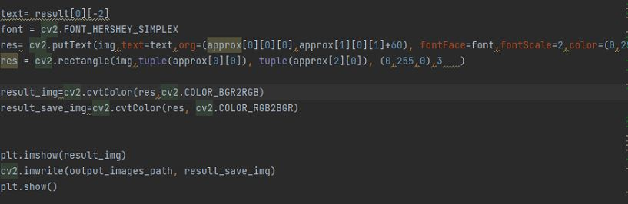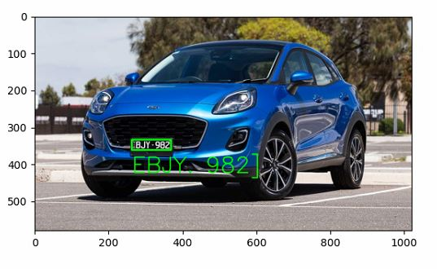

WEB DESİGN

